ASSIGNMENT 4

|  |  |
| --- | --- |
| Date | 6 nov 2022 |
| Team ID | PNT2022TMID26079 |
| Project Name | Gas Leakage Monitoring and Alerting System |
| Name | RUSHENDHAR PS |

# Write code and connections in wokwi for ultrasonic sensor. Whenever distance is less than 100 cms send alert to ibm cloud and display in device recent events.

**Upload document with wokwi share link and images of ibmcloud.**

# CODE:

#include <WiFi.h>

#include <PubSubClient.h> WiFiClient wifiClient;

String data3;

#define ORG "9djwz2"//IBM ORGANITION ID

#define DEVICE_TYPE "sanjay"//Device type mentioned in ibm watson IOT Platform #define DEVICE_ID "1234567"//Device ID mentioned in ibm watson IOT Platform #define TOKEN "12345678"

#define speed 0.034

#define led 14

char server[] = ORG ".messaging.internetofthings.ibmcloud.com"; char publishTopic[] = "iot-2/evt/event_1/fmt/json";

char topic[] = "iot-2/cmd/led/fmt/String"; char authMethod[] = "use-token-auth"; char token[] = TOKEN;

char clientId[] = "d:" ORG ":" DEVICE_TYPE ":" DEVICE_ID;

PubSubClient client(server, 1883, wifiClient);

const int trigpin=5; const int echopin=18; String command; String data="";

long duration; float dist;

void setup()

{

Serial.begin(115200); pinMode(led, OUTPUT); pinMode(trigpin, OUTPUT); pinMode(echopin, INPUT); wifiConnect(); mqttConnect();

}

void loop() {

bool isNearby = dist < 100; digitalWrite(led, isNearby);

publishData(); delay(500);

if (!client.loop()) { mqttConnect();

}

}

void wifiConnect() {

Serial.print("Connecting to "); Serial.print("Wifi"); WiFi.begin("Wokwi-GUEST", "", 6);

while (WiFi.status() != WL_CONNECTED) { delay(500);

Serial.print(".");

}

Serial.print("WiFi connected, IP address: "); Serial.println(WiFi.localIP());

}

void mqttConnect() {

if (!client.connected()) {

Serial.print("Reconnecting MQTT client to "); Serial.println(server); while (!client.connect(clientId, authMethod, token)) { Serial.print(".");

delay(500);

}

initManagedDevice(); Serial.println();

}

}

void initManagedDevice() { if (client.subscribe(topic)) {

// Serial.println(client.subscribe(topic)); Serial.println("IBM subscribe to cmd OK");

} else {

Serial.println("subscribe to cmd FAILED");

}

}

void publishData()

{

digitalWrite(trigpin,LOW); digitalWrite(trigpin,HIGH); delayMicroseconds(10); digitalWrite(trigpin,LOW); duration=pulseIn(echopin,HIGH); dist=duration*speed/2; if(dist<100){

String payload = "{\"Alert Distance\":"; payload += dist;

payload += "}";

Serial.print("\n"); Serial.print("Sending payload: "); Serial.println(payload);

if (client.publish(publishTopic, (char*) payload.c_str())) { Serial.println("Publish OK");

}

}

if(dist>100){

String payload = "{\"Distance\":"; payload += dist;

payload += "}";

Serial.print("\n"); Serial.print("Sending payload: "); Serial.println(payload);

if(client.publish(publishTopic, (char*) payload.c_str())) { Serial.println("Publish OK");

}else {

Serial.println("Publish FAILED");

}

}

}

## Wokwi link:

https://wokwi.com/projects/347956062652990036

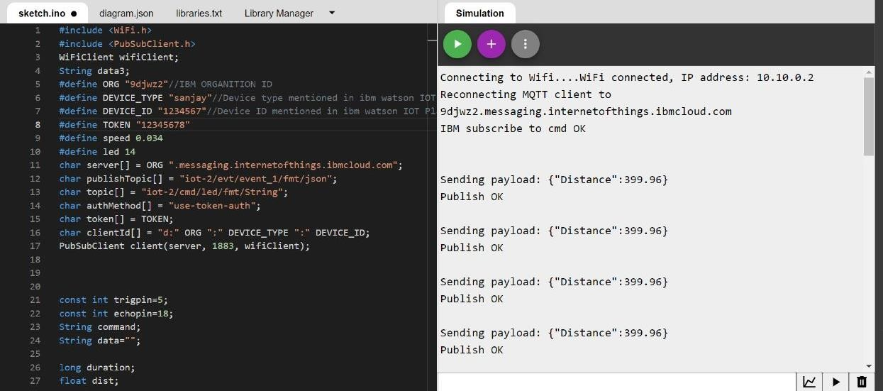**output:**

**WOKWI:**

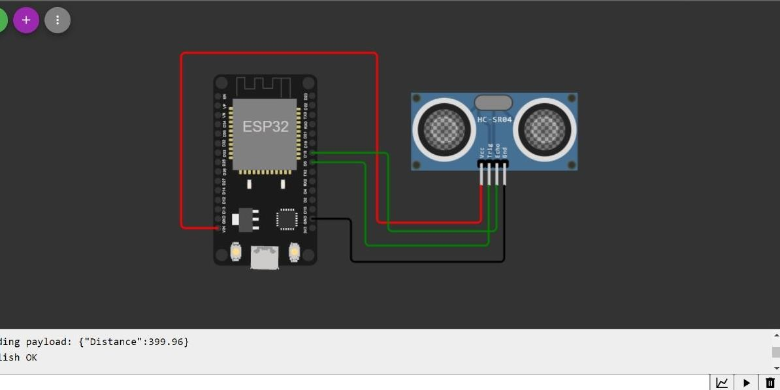

## IBM CLOUD:

